**COMET BAY COLLEGE**

**Physics Unit 3 - Task 3**

**Circular Motion Pre-Test**

**Name: Total Marks /15**

**Aim:** To study how force is affected when changing the radius for an object moving in a circular path.

**Hypothesis:** ____________________________________________________________________________________________________________________________________________________________________________________________________________________________________________________________________________________________________________________________________________________________________________________________

**Independent Variable:** ________________________________________________________

**Dependent Variable:** _________________________________________________________

**Controlled Variables:** _________________________________________________________

_________________________________________________________

**Material:**

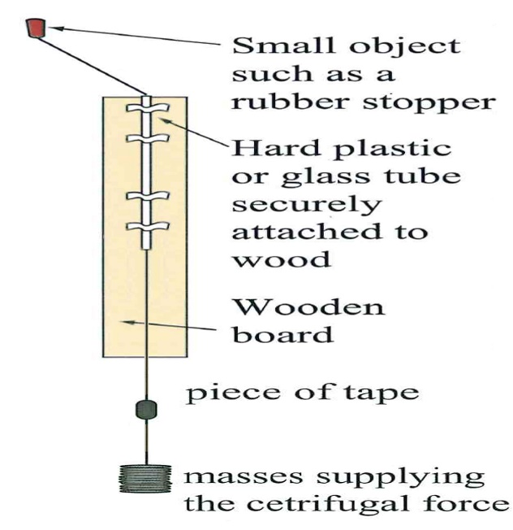

**Figure 1: Set up of apparatus used to verify equilibrium**

|  |  |
| --- | --- |
| * Circular Motion Apparatus (see Figure 1) | |
| * Large rubber stopper * Slotted mass (500 g) * White tape (as a marker) | * Fishing Line * Stop watch |

**Method:**

1. Set up equipment as shown in Figure 1.
2. Place a mass of 250 g on the end of the fishing line.
3. Place the white tape on the fishing line so when it is in line with the bottom of the wooden board, the stopper has a radii of 200 mm of line extending it from the top of the plastic tube.
4. Whirl the stopper horizontally at a speed required to raise the tape to be in line with the bottom of the board.
5. Record the time for 20 revolutions in Table 1.
6. Repeat this for two more trials in Table 1.
7. Repeat the process for Table 2 and Table 3, but change the radii to 300 mm and 400 mm. In each case, keep the 250 g mass on the end of the fishing line unchanged.

**Practical Results:** (6 marks)

**Table 1: Recorded data of stopper revolving with a variable radius.**

|  |  |  |  |  |  |  |  |
| --- | --- | --- | --- | --- | --- | --- | --- |
|  |  | Time for 20 turns | | | Average time per turn (s) | Velocity  (m s-1) | Velocity2  (m2 s-2) |
| Radius (m) | | Trial 1 | Trial 2 | Trial 3 |
|  | |  |  |  |  |  |  |

**Table 2: Recorded data of stopper revolving with a variable radius.**

|  |  |  |  |  |  |  |  |
| --- | --- | --- | --- | --- | --- | --- | --- |
|  |  | Time for 20 turns | | | Average time per turn (s) | Velocity  (m s-1) | Velocity2  (m2 s-2) |
| Radius (m) | | Trial 1 | Trial 2 | Trial 3 |
|  | |  |  |  |  |  |  |

**Table 3: Recorded data of stopper revolving with a variable radius.**

|  |  |  |  |  |  |  |  |
| --- | --- | --- | --- | --- | --- | --- | --- |
|  |  | Time for 20 turns | | | Average time per turn (s) | Velocity  (m s-1) | Velocity2  (m2 s-2) |
| Radius (m) | | Trial 1 | Trial 2 | Trial 3 |
|  | |  |  |  |  |  |  |

**Questions:**

1. Explain the principles and any background knowledge on the theory of horizontal circular motion. Also consider the principals should the mass be changed rather that the radius. What relationship is there between the hanging mass and the stopper, when the apparatus is in motion? (2 marks)

____________________________________________________________________________________________________________________________________________________________________________________________________________________________________________________________________________________________________________________________________________________________________________________________________________________________________________________________________________________________________________________________________________________________________________________________________________________________________________________________________________________________________________________________________________________________________________________________________________________________________________________________________________________________________________________________________________________________________________________________________________________________________________________________________________________________________________________________________________________________________________________________________________________________________________________________________________________________________________________________________________________________________________________________________________________________________________________________________________________________________________________

1. Calculate the expected percentage uncertainty for the results in table 1 only when considering the devices used. (2 marks)
2. Plot radius versus velocity (include the error bars for 200 g). (2 marks)
3. On the same graph paper, but using a secondary vertical axis plot radius versus velocity squared (include the error bars for 200 g). (2 marks)



1. Use the correct graph to determine the centripetal force, Fc. (1 mark)
2. Discuss any errors and how they would affect the results. (2 marks)

____________________________________________________________________________________________________________________________________________________________________________________________________________________________________________________________________________________________________________________________________________________________________________________________________________________________________________________________________________________________________________________________________________________________________________________________________________________________________________________________________________________________________________________________________________________________________________________________________________________________________________________________________________________________________________________________________________________________________________________________________________________________

1. A major error of this experiment is that the mass is not spinning horizontally. Briefly describe how this can affect the experiment?

____________________________________________________________________________________________________________________________________________________________________________________________________________________________________________________________________________________________________________________________________________________________________________________________________________________________________________________________________________________________________________________________________________________